**Effects of anthropogenic noise on haul-out numbers of harbor seals (*Phoca vitulina)***

Kyra Bankheada, Grace Freemanb, Wyatt Heimbichner Goebela & Alejandro Acevedo-Gutiérreza.

aDepartment of Biology, Western Washington University, 516 High St., Bellingham, WA, 98225-9160, USA

Corresponding Author: **Kyra Bankhead** (email: bankheak@oregonstate.edu)

**Abstract**

Haul-out sites of harbor seals (*Phoca vitulina*) include areas with high levels of anthropogenic noise. In some cases, seals haul out at night when there are lower in-air noise levels. However, it is unclear if there are additional responses to noise pollution. To determine potential impacts of anthropogenic noise on haul-out behavior, we compared numbers of hauled-out harbor seals relative to in-air noise levels at two sites in Washington State, USA —one close to human activities (Bellingham waterfront) and one more distant (Semiahmoo marina)— between July 2020 and August 2021. We used Generalized Linear Mixed Models to identify predictors of seal numbers. The marina had lower mean noise levels than the waterfront (39.7 ± SD 6.1 dB, n = 29 observations versus 51.2 ± SD 5.2 dB, n = 126 observations). The plotted model prediction showed a significantly negative association between noise and seals at the marina, and no association was found at the waterfront. Results indicate that in-air noise levels may influence seal numbers at sites where human activities are low. They also suggest that, besides hauling-out at night, seals may become tolerant to in-air noise levels at sites where human activities are high.

**Key words:** harbor seal, *Phoca vitulina,*anthropogenic noise, haul-out behavior, Salish Sea

**Introduction**

Human settlements are very common along coastlines; worldwide, over 37% of humans live ≤100 km from the seacoast, a percentage that continues to increase (United Nations 2017). Along these coastlines, human activity can overlap crucial marine mammal habitat such as haul-out locations where pinnipeds (seals, fur seals, sea lions, and the walrus) temporarily leave the water to rest or thermoregulate (Watts 1996). In the highly developed northern hemisphere, the ubiquitous distribution of harbor seals (*Phoca vitulina*) means their interactions with humans are relatively high, making them a suitable candidate to study the impact of human disturbance due to development. When disturbed by humans, harbor seals on land typically rush into the water (Terhune and Almon 1983; Allen et al. 1984; Ruiz-Mar et al. 2022). With long-term exposure, consequences of repeated disturbance on seals include reducing the amount of time spent nursing their pups (Ruiz-Mar et al. 2022), delaying the return to the haul-out site (Paterson et al. 2019), hauling-out at times of day when disturbance is low (Grigg et al. 2002; London et al. 2012), avoiding areas of high disturbance (Montgomery et al. 2007), or possibly abandoning a haul-out site (Newby 1973). One component of disturbance related to human development is in-air noise pollution; however, to our knowledge, few studies have examined the influence of in-air noise level on the haul-out behavior of harbor seals.

Factors influencing the haul-out behavior of harbor seals are numerous and appear to be site-specific, but they include season, tide level, air temperature, wind speed, and precipitation (London et al. 2012; Granquist and Hauksson 2016). Determining cause and effect of harbor seal haul-out behavior has proven difficult given the large number of variables and the challenges of conducting controlled experiments. To increase our understanding of the impacts of anthropogenic noise on harbor seals, we conducted a comparative study on the haul-out behavior of harbor seals between two similar haul-out sites —one close to human activities and one away from them.

Urban areas have high levels of anthropogenic activities that generate in-air noise pollution. In downtown Bellingham, Washington State, USA, an industrial pond along the Whatcom Creek Waterway housed a strand of logs known as the log boom where harbor seals used to haul-out (Farrer and Acevedo-Gutiérrez 2010). In the spring of 2008, however, demolition began on a large-scale remediation project (Port of Bellingham, 2019). This remediation project included demolition, construction, shipping of materials, and increased foot and vehicle traffic of workers, causing an increase in noise levels during the day (Acevedo-Gutiérrez and Cendejas-Zarelli 2011). Between 2015 and 2016 the log boom was removed, and seals have been hauling out on wooden dock structures called pilons along the waterfront instead. Because harbor seals use this site to haul-out, noise disturbance may affect their haul-out patterns due to the energetic cost of frequent flushes into the water (Karpovich et al. 2015). Moreover, Acevedo-Gutiérrez and Cendejas-Zarelli (2011) reported lower in-air noise levels and higher numbers of harbor seals hauled-out at night than during the day at the Bellingham waterfront after the remediation project began. However, it is still unclear if noise pollution in Bellingham is the cause of this observed nocturnal haul-out pattern and whether there are additional impacts of noise pollution over longer periods of time.

To determine if anthropogenic noise levels influenced harbor seal haul-out behavior, we examined the number of hauled-out harbor seals relative to in-air noise level and other environmental variables at the Bellingham waterfront twelve years after the study of Acevedo-Gutiérrez and Cendejas-Zarelli (2011) and at a haul-out site with low anthropogenic activities, the Semiahmoo marina (Patterson and Acevedo-Gutiérrez 2008). We hypothesized that in-air noise levels at the waterfront would be significantly higher than at the marina, and that there would be a significant negative relationship between anthropogenic noise level and the number of seals hauled-out at both sites.

**Methodology**

Study Sites

The Bellingham waterfront haul-out site is in Bellingham Bay at the former Georgia Pacific paper mill (48º 44' N, 122º 29' W) (Figure 1). The site was accessible at any tide level and covers an area of approximately 18,650 $m^{2}$, 700 $m^{2}$ of which was available haul-out area for the seals. This site consists of two locations (East and West) with floating pilons approximately 250 m from one another (Figure 1). These locations were surveyed separately to observe all the pilons on which the harbor seals haul out. The human activity in this area was high due to a public beach next to the waterfront as well as construction to develop the terrain into commercial land. The Semiahmoo marina haul-out site is in Drayton Harbor (48° 59.11' N, 122° 46.42' W), about 34 km from the waterfront (Figure 1). The marina consists of three connected floating water breakers that harbor seals use as a haul-out site and that are accessible at all tide levels. The site covered an area of approximately 40,000 $m^{2}$, 1,180 $m^{2}$ of which was available haul-out area for the seals. The marina was exposed to less activity than the waterfront due to exclusive access to its dock and the relative seclusion of the area.

Data collection

Observations were conducted between July 2020 and August 2021 by trained undergraduate students at Western Washington University. The students observed harbor seals at the waterfront three days per week during daylight hours. Each survey sample consisted of two students who recorded the number of harbor seals observed hauled-out within the location’s range in a period of three minutes. The only regular pinniped found at the sites is the harbor seal, occasionally California sea lions (*Zalophus californianus*) briefly visited the waterfront. Following Monckton et al. (2020), all students were trained to identify the harbor seal species using binoculars to distinguish their lack of pinnae, round head, blunt snout, hind flippers unable to point forward, and variable color pattern, including the presence of spots. To ensure that harbor seals were not counted twice among locations, the survey on the second location was conducted < 5 min from the end of the survey on the first location (East or West, haphazardly selected). We observed harbor seals at the marina once per week during daylight hours following the methods used at the waterfront site. Observations were conducted from a 6-m-high bluff located along a public pathway and facing the three floating water breakers protecting the marina. All three locations (the two sites at the waterfront and that one at the marina) had consistent land markers to ensure each survey was conducted from the same on-land spot > 100 m from the seals.

We used 10 × 40 binoculars to record the total number of adult harbor seals and pups hauled-out. The in-air sound pressure levels (SPLs) were measured as an indicator of the amount of anthropogenic noise around each haul-out site. SPLs were consistently recorded 100 m from the haul-out location using a NM102 Sound Level Meter (Noise Meters USA, Houston, USA). The NM102 sound level meter has a resolution and accuracy of 0.1 dB ± 1.5 dB (re: 94 dB @ 1 kHz, in air), a frequency range of 31.5 Hz to 8 kHz, and a selectable noise level range of 30 to 130 dB(A) and 35 to 130 dB(C) re 20 µPa. The NM102 sound level meter has been employed to measure in-air noise in other studies (Asuquo et al. 2001). The A-weighting curve and the C-weighting curve are commonly used curves employed to measure SPLs, as they measure frequency and amplitudes respectively within a human’s auditory range (Skilling and Munro 2016), which is very similar to the harbor seal’s in-air auditory range (Mohl 1968). During each survey, the dB values were monitored and recorded every 30 seconds over a three-minute interval then averaged at the beginning of the survey using the omnidirectional microphone of the sound level meter. SPL readings were taken with a windshield attached to the noise meter to avoid over-clustering of noise readings.

To account for other factors that might have influenced the numbers of harbor seals hauled-out, we recorded date, time of day, weather condition, air temperature and tide level during each observation. We used the wxtide47 program to find the tide levels at each observation start time. To ensure that the hypotheses’ underlying assumption that the marina site was an area of lower human activity than the waterfront, we also recorded human activities that occurred during the 3-minute count intervals such as air, vessel, construction, and pedestrian traffic (Osinga et al. 2012; Paterson et al. 2019; Ruiz-Mar et al. 2022). Foot traffic was tallied as pedestrians walking or running ≤ 100 m from seals, and vessel traffic was tallied when any type of watercraft approached ≤ 100 m from seals. Air traffic was tallied when observers heard helicopters or planes flying over the site; construction traffic was tallied when observers heard noise from construction machinery.

All data collection complied with the USA Marine Mammal Protection Act and did not require additional permitting as determined by Western Washington University’s Animal Care and Use Committee.

Data analysis

Statistical analyses were conducted using R statistical software (R Core Team, 2021). Due to the nonnormality and unequal variances in noise levels between sites, we ran a Mann-Whitney U-test to determine if mean noise levels were different between sites. Because the noise levels at the two waterfront locations exhibited normality and equal variances, we examined whether they were exposed to significantly different levels of sound using a t-test. Due to lack of significant difference in noise levels between locations found from the t-test, we collapsed the two locations into a single seal count/noise measurement. The seal counts were summed together whereas the sound measurements were averaged into one survey sample.

To examine the potential effect of anthropogenic noise levels on the number of harbor seals hauled-out, we related our response variable (number of seals hauled-out) to several predictor variables: in-air noise level, month, tide level, and time of day. Temperature and weather measurements were excluded from the list of predictors due to the lack of location-specific measurement tools. Given that some of these predictors were expected to change inconsistently over time (Lyons 2018), we analyzed the data with Generalized Linear Mixed Models (GLMMs). GLMMs are the best tools for analyzing count data when multiple fixed and random effects are present (Zuur et al. 2009). Additionally, we found evidence for temporal autocorrelation in seal numbers by plotting the residual’s change in serial correlation over intervals of observations through the autocorrelation function (ACF) as well as the residual diagnosis in the DHARma package (Hartig, 2022). Generalized estimating equation models (GEEs) can account for temporal autocorrelation, but they lack the ability to account for the zero-inflation and overdispersion in data with a negative binomial distribution. Therefore, we used GLMMs and included an autoregressive effect to regress each value to its previous observation. Autoregressive models allow for the inclusion of a parameter that accounts for temporal autocorrelation structuring one temporal variable within another (Kissling and Carl, 2008). Based on the results of the temporal autocorrelation analysis, we selected Julian date as the autocorrelation parameter within the variable month. We checked for collinearity between predictor variables using the Performance package (Lüdecke et al. 2021) and found no correlation between independent variables. Seal counts were checked for over-dispersion due to a lack of independence between counts in the response variable, leading to the variance being higher than the mean (Burnham and Anderson 2002). We used the dispersion ratio (dr) in the Pearson's Chi-Squared test where no dispersion would give a ratio of zero (Bolker et al. 2009).

Given our interest in the variations in seal numbers relative to noise within each site, we included a fixed effect for site and an interaction between noise and site to address the effects of in-air noise levels on the haul-out behaviors of seals among sites. This interaction allowed the model to determine whether the variability in the data was best explained by the different responses to in-air noise by seals at the two sites. Candidate models ranged from the null model (# of hauled-out seals ~ 1) to a full model including all the terms of interest, as well as a model that replaced the interaction term between site and noise with additive terms. The full model included only fixed effects that were expected to be directly related to seal haul-out behavior to avoid over-parameterizing the model. These variables included month to account for the effect of season, tide level and time of day, which affect haul-out behavior (London et al. 2012; Granquist and Hauksson 2016). Models were compared using the second order Akaike Information Criterion (AICc) because of its ability to correct for smaller sample sizes and outperform traditional AIC even for large sample sizes (Brewer et al. 2016). In the model comparison, a lower AICc value indicated a better-fit model. The individual parameters/interactions were assumed to be significant if the model with that parameter was selected over a model without it.

Over-dispersion was found in the combined site data set with the Poisson distribution (dr = 6.74, p < 0.001). In addition, the package Performance (Lüdeckel et al. 2021) indicated zero inflation in the response variable, suggesting that excess zeros were generated by a separate process from the count values and can be modeled independently (Long and Freese 2006). These outcomes and the density graphs for the response variable (Figure 2), indicated that using a negative binomial model with a zero-inflation factor was required for the candidate models (Bolker et al. 2009).

**Results**

A total of 229 surveys were conducted across the year-long study period (175 at the waterfront and 54 at the marina). The two study sites were used differently by harbor seals. The marina site was used nearly year-round by large numbers of harbor seals, whereas the waterfront site had consistent use by seals during the pupping/breeding/molting season (June through November) (Huber et al. 2001). Given this differential use, we only used data for both the waterfront and marina from the months of June-November. Incorporating the large number of zero counts of December-May could be attributed to a life history process unrelated to in-air noise and thus reduce our ability to determine the response of seals to sound. Therefore, during the narrowed sample period (June-November), harbor seals spend more time hauled-out than during other parts of the year and could spill over into haul-out habitat that is never or rarely used during other months, as observed at the waterfront location.

After dropping data from the months of December-May, a remaining total of 155 samples were included in the analyzed models (126 at the waterfront and 29 at the marina). The total number of seals peaked in August at the marina and in July at the waterfront (Figure 3). Within these peak months, the median number of hauled-out harbor seals was nearly 10 times larger at the marina than at the waterfront (waterfront: Med: 14 seals, IQR = 9, n = 27 observations; marina: Med: 64 seals, IQR = 51, n = 9 observations). The total number of seals peaked in the afternoon (12:00-15:00) at both the waterfront and marina (waterfront: Med: 6 seals, IQR = 8, n = 61 observations; marina: Med: 43 seals, IQR = 46, n = 4 observations).

The Mann-Whitney U test showed a significant difference in mean in-air noise levels between sites (W = 324.5, p = << 0.001, n = 155). The waterfront had an average in-air noise level of 51.2 ± 5.2 dB whereas the average in-air noise level at the marina was 39.7 ± 6.1 dB (Figure 4). Human-related activities ≤ 100 m from harbor seals were recorded on 83.3% of observations at the waterfront and 17.2% of observations at the marina. Vessel traffic was the most frequent human activity at both sites compared to construction, air, and pedestrian traffic. Vessel traffic comprised 43.0% of the human-related activities at the waterfront and 60.0% at the marina. Construction traffic was the second most frequent human activity at the waterfront (30.5% of activities) and pedestrian traffic was the second most common human activity at the marina (40.0% of activities).

The most parsimonious GLMM included only an interaction between site and noise as predictors for the number of harbor seals hauled out (Table 1). To further investigate whether noise level was a significant predictor of the number of harbor seals hauled-out between sites, we calculated and plotted the differences in the slope/intercept of the predicted number of seals hauled-out in relationship to in-air noise levels at each site. We found that the seals at the waterfront were less affected by noise level than those at the marina (Figure 5).

**Discussion**

Our data support the hypothesis that the Bellingham waterfront, with high anthropogenic activity, would have higher in-air noise levels relative to the Semiahmoo marina with lower overall anthropogenic activity (Figure 4). Human-related activities were also more frequent at the waterfront than at the marina, further supporting this hypothesis. We also hypothesized that within sites, harbor seal haul-out numbers would significantly decrease as ambient noise level increased. This hypothesis was supported at the marina, but not at the waterfront (Figure 5). Seals at the waterfront were subjected to more noise on average and higher traffic than at the marina, yet their hauled-out numbers accounted for a small proportion of the variation in noise levels between sites.

The relationship between noise level and seal numbers at the marina and the lack of such relationship at the waterfront suggests that seals at the waterfront may be habituated to higher noise levels than those at the marina. This habituation could be because frequently repeated exposure to long durations of anthropogenic noise can cause diminished responses to acoustics signals that would otherwise make harbor seals flush into the water. Our results on human activities also support the habituation hypothesis, as there was less traffic at the marina than at the waterfront, which could have resulted in seals being more responsive to in-air noise disturbance at the marina. The heightened response in areas of low activity has been described elsewhere. For instance, harbor seals at sites with low vessel activity flush more readily in response to boats than those at high activity sites (Cates and Acevedo-Gutiérrez 2017). Although vessel traffic was the most frequent human activity at both sites, the marina had a much lower overall frequency of vessel traffic which could have been correlated to the low/zero sample measurements in haul-out abundance. Additionally, changes in the frequency of human activity over long time periods impeded orienting behavior in other seal species due to their inability to habituate to irregular stimuli (Van Polanen Petel et al. 2008). Because human activity at the marina was typically lower than at the waterfront, seals could have been startled by variable increases in traffic and therefore avoid hauling-out in those conditions.

Besides noise levels, the haul-out behavior of seals at the marina and waterfront were not affected by other environmental influences. This contradicts other studies that have found patterns with these abiotic variables, such as an effect of time of day that was observed in the haul-out behavior of Weddell seals (*Leptonychotes weddellii*) (Lake et al. 1997). Maximum haul-out in these cases occured during the afternoon in the molting season because it is usually the warmest time of the day (Lake et al. 1997; Carlens et al. 2006). However, we did not find evidence that the time of day affected the number of seals hauled-out, which could be due to the narrow range of the times of day that observations took place (Q1: 11am; Q3: 3pm). Additionally, the lack of influence by the tide level in the model’s parameters could be because both haul-out sites were available at all tide levels.

Our seal counts at the waterfront where far lower than those reported during the daytime twelve years prior by Acevedo-Gutiérrez and Cendejas-Zarelli (2011), suggesting that human development and/or log removal has affected the presence of seals in the area since 2009. Sound levels within the two study periods were also vastly different; noise levels averaged around 75.3 dB in 2009 compared to our average noise levels of 51.2 dB. The difference in noise levels is most likely due to the COVID-19 pandemic that took place during our study period, as many people were forced to stay home away from the Bellingham waterfront. Nonetheless, Acevedo-Gutiérrez and Cendejas-Zarelli (2011) found that the number of harbor seals hauled-out during the day decreased as noise increased, a relationship that was not found in our results. The difference between the two studies could be the result of the two previously described long-term effects. Seals being habituated to relatively high noise levels could have been unaffected by the relatively low disturbance during the pandemic and therefore elicited no response in the seals at the waterfront. Additionally, the decrease in harbor seal abundance between study periods could have also affected the variation in seal counts and therefore the effect of noise levels on this measurement.

Across sites, there were more harbor seals hauled-out at the marina throughout the sample period, where noise level and human disturbance was lower. It is unclear if the high seal numbers at the marina were related to noise levels or to another factor such as the size of the haul-out platform (700 $m^{2}$ at the waterfront versus 1,180 $m^{2}$ at the marina) or the proximity of nearby foraging grounds.Although the haul-out area at the marina was larger than that of the waterfront, seals at the marina stuck close together on one outstretched dock for most observations, effectively occupying a very small area. Little is known about foraging grounds for both sites, seals at the marina do appear to forage on a variety of prey in the adjacent estuary (Luxa and Acevedo-Gutiérrez 2013) whereas seals at the waterfront are suspected to prey on migrating salmon in the nearby Whatcom Creek during the Fall salmon run (Farrer and Acevedo-Gutiérrez 2010). One caveat of our study is the lack of nocturnal observations, due to safety concerns for observers, which would have teased out any diurnal factors that could affect haul-out patterns. If the less tolerant members of the population relocate to nocturnal haul-outs, then our focus group (i.e., the daylight group on which observations were taken) could have been biased towards more tolerant individuals. That is, we could have only been measuring responses in those who learn to ignore nonthreatening stimuli rather than those who displace themselves from it (Bejder et al. 2009). Therefore, the interpretation of harbor seal aversion to haul-out, whether that be due to disturbances or other natural motivations, is limited to our low/zero haul-out count of harbor seals and cannot be parsed out by this analysis. Rather the focus of this study was to investigate the correlation between ambient noise level and the number of harbor seals hauled-out with an indicator variable accounting for level of human activity.

Managing anthropogenic noise pollution relies on spatial and temporal threat assessments. Buffer zones have been established by the National Oceanic and Atmospheric Administration of the US for managing marine mammals and preventing their harassment. Our results suggest that noise buffers should be implemented relative to level of human activity: at greater distances in areas where harbor seals are exposed to reduced human activity. There are already a few successful and cost-effective noise reduction methods in place, including the implementation of vegetation to reduce roadside traffic levels (Kalansuriya et al. 2009). To minimize seal disturbance, these designs need to be implemented around haul-out sites.

We found a negative relationship between harbor seal haul-out numbers and anthropogenic in-air noise levels in an area of low anthropogenic activity (the marina). At a site with high levels of anthropogenic activity (the waterfront), we detected evidence of habituation to in-air noise levels. It is currently unknown if seals at the waterfront still haul-out more at night than during the day. However, our results provide evidence that harbor seals vary their response over time at sites with high levels of human activity. These findings guide the development of flexible sound buffer designs formulated to the level of human activity in pinniped haul-out areas.

**Acknowledgements**

We thank P. Thut for providing logistical support, and K. Baumgarten and the Port of Bellingham for providing access to the Bellingham waterfront site. We also thank the many undergraduate students in the Marine Mammal Ecology Lab at Western Washington University that made detailed observations every week.

Data availability

The data generated and analyzed during this study are available on the harbor-seal GitHub repository (https://github.com/bankheak/harbor-seal).

**Author information**

Author ORCIDs

Kyra Bankhead https://orcid.org/0000-0002-5194-2802

Alejandro Acevedo-Gutiérrez https://orcid.org/0000-0002-9128-826X

Competing interests

The authors declare no competing interests.

Funding information

The Biology Department at Western Washington University and the Francis and Alfred Baker Memorial Grant Scholarship supported K. Bankhead.

Author contributions

K.B, W.H.-G., and A.A.-G. contributed to project design. K.B. collected the data. G.F. and K.B. conducted data analysis. K.B. and A.A.-G. were the primary writers of the manuscript, and all other authors assisted in editing the manuscript.

**References**

Acevedo-Gutiérrez, A., and Cendejas-Zarelli, S. 2011. Nocturnal haul-out patterns of harbor seals (*Phoca vitulina*) related to airborne noise levels in Bellingham, Washington, USA. Aquatic Mammals. **37**(2): 167-174. doi:10.1578/AM.37.2.2011.167.

Allen, S.G., Ainley, D.G., and Page, G.W. 1984. Patterns at Bolinas Lagoon, California. Fishery Bulletin. **82(**3-4): 493.

Asuquo, U.E., Menkiti, A.I., Onnu, M., and Opaluwa, E.H.O. 2001. Environmental noise studies in some areas of Calabar and Uyo, Nigeria. Global Journal of Pure and Applied Sciences. **7**(2): 339-344.

Bejder, L., Samuels, A., Whitehead, H., Finn, H., and Allen, S. 2009. Impact assessment research: use and misuse of habituation, sensitisation and tolerance in describing wildlife responses to anthropogenic stimuli. Marine Ecology Progress Series. **395**: 177-185. doi:10.3354/meps07979.

Bolker, B.M., Brooks, M.E., Clark, C.J., Geange, S.W., Poulsen, J.R., Stevens, M.H.H. and White, J.S.S. 2009. Generalized linear mixed models: a practical guide for ecology and evolution. Trends in Ecology and Evolution. **24**: 3. doi:10.1016/j.tree.2008.10.008.

Brewer, M.J., Butler, A. and Cooksley, S.L. 2016. The relative performance of AIC, AICC and BIC in the presence of unobserved heterogeneity. Methods Ecol Evol. **7**: 679-692. https://doi.org/10.1111/2041-210X.12541.

Burnham, K.P., and Anderson, D.R. 2002. Model Selection and Multimodel Inference: A practical information-theoretic approach. Springer-Verlag, New York. doi:10.1007/978-1-4757-2917-7_3.

Carlens, H., Lydersen, C., Krafft, B.A., and Kovacs, K.M. 2006. Spring haul‐out behavior of ringed seals (Pusa hispida) in Kongsfjorden, Svalbard. Marine Mammal Science. **22**(2): 379-393.

Cates, K., and Acevedo-Gutiérrez, A. 2017. Harbor seal (*Phoca vitulina*) tolerance to vessels under different levels of boat traffic. Aquatic Mammals. **43**(2): 193.

Farrer, J., and Acevedo-Gutiérrez, A. 2010. Use of haul-out sites by harbor seals (*Phoca vitulina*) in Bellingham: Implications for future development. Northwestern Naturalist. **91**(1): 74–79. doi:10.1898/nwn08-46.1.

Granquist, S., and Hauksson, E. 2016. Seasonal, meteorological, tidal and diurnal effects on haul-out patterns of harbour seals (*Phoca vitulina*) in Iceland. Polar Biology. **39**: 2347-2359. doi:10.1007/s00300-016-1904-3.

Grigg, E.K., Green, D.E., Allen, S.G., and Markowitz, H. 2002. Nocturnal and diurnal haul-out patterns of harbor seals (*Phoca vitulina richardsi*) at Castro Rocks, San Francisco Bay, California. California Fish and Game. **88**(1): 15-27.

Hartig, F. 2022. DHARMa: Residual Diagnostics for HierARchical Models. Retrieved February 17, 2023, from https://github.com/florianhartig/DHARMa.

Huber, H.R., Jeffries, S.J., Brown, R.F., DeLong, R.L., and Vanblaricom, G. 2001. Correcting aerial survey counts of harbor seals (*Phoca vitulina richardsi*) in Washington and Oregon. Marine Mammal Science. **17**, 276-293. doi:10.1111/j.1748-7692.2001.tb01271.x.

Kalansuriya, C.M., Pannila, A.S., and Sonnadara, D.U.J. 2009. Effect of roadside vegetation on the reduction of traffic noise levels. Proceedings of the Technical Sessions. **25**: 1-6.

Karpovich, S.A., Skinner, J.P., Mondragon, J.E., and Blundell, G.M. 2015. Combined physiological and behavioral observations to assess the influence of vessel encounters on harbor seals in glacial fjords of southeast Alaska. Journal of Experimental Marine Biology and Ecology. **473**: 110-120. doi:10.1016/j.jembe.2015.07.016.

Kissling, W.D. and Carl, G. 2008. Spatial autocorrelation and the selection of simultaneous autoregressive models. Global Ecol. Biogeogr. **17**: 59– 71. doi:10.1111/j.1466-8238.2007.00334.

Lake, S., Burton, H. and Hindell, M. 1997. Influence of time of day and month on Weddell seal haul-out patterns at the Vestfold Hills, Antarctica. Polar Biol. **18:** 319-324. doi:10.1007/s003000050194.

London, J.M., Ver Hoef, J.M., Jeffries, S.J., Lance, M.M., and Boveng, P.L. 2012. Haul-out behavior of harbor seals (*Phoca vitulina*) in Hood Canal, Washington. PLoS One. **7**(6): e38180. doi:10.1371/journal.pone.0038180.

Long, J.S., and Freese, J. 2006. Regression models for categorical dependent variables using Stata. Stata Press Publication. **7:** 250-255.

Lüdeckel, D., Ben-Shachar, M.S., Patil, I., Waggoner, P., and Makowski, D. 2021. Performance: An R package for assessment, comparison and testing of statistical models. Journal of Open Source Software. **6(**60): 3139. doi:10.21105/joss.03139.

Luxa, K., and Acevedo-Gutiérrez, A. 2013. Food habits of harbor seals (*Phoca vitulina*) in two estuaries in the central Salish Sea. Aquatic Mammals. **39**(1): 10.

Lyons, M. 2018. Generalised additive models (GAMS): An introduction. Environmental Computing. Retrieved January 9, 2022, from http://environmentalcomputing.net/intro-to-gams.

Mohl, B. 1968. Auditory sensitivity of the common seal in air and water. Journal of Auditory Research. **8(**1): 27–38.

Monckton, S.K., Johal, S., and Packer, L. 2020. Inadequate treatment of taxonomic information prevents replicability of mozt zoological research. Canadian Journal of Zoology. **98**(9): 633-642.

Montgomery, R.A., Ver Hoef, J.M., and Boveng, P.L. 2007. Spatial modeling of haul-out site use by harbor seals in Cook Inlet, Alaska. Marine Ecology Progress Series. **341**: 257-264.

Newby, T.C. 1973. Observations on the breeding behavior of the harbor seal in the state of Washington. Journal of Mammalogy. **54**(2): 540-543.

Osinga, N., Nussbaum, S.B., Brakefield, P.M., and de Haes, H.A.U. 2012. Response of common seals (*Phoca vitulina*) to human disturbances in the Dollard estuary of the Wadden Sea. Mammalian Biology. **77**(4): 281-287.

Paterson, W.D., Russell, D.J., Wu, G.M., McConnell, B., Currie, J.I., McCafferty, D.J., and Thompson, D. 2019. Post-disturbance haulout behaviour of harbour seals. Aquatic Conservation: Marine and Freshwater Ecosystems. **29**: 144-156. doi:10.1002/aqc.3092.

Patterson, J., and Acevedo-Gutiérrez, A. 2008. Tidal influence on the haul-out behavior of harbor seals (*Phoca vitulina*) at a site available at all tide levels. Northwestern Naturalist. **89**(1): 17-23. doi:10.1898/1051-1733(2008)89.

Port of Bellingham, WA. 2019. Final waterfront district master plan documents[Online]. Available from: https://www.portofbellingham.com/560/Final-Master-Plan-Documents.

R Core Team. 2021. R: A language and environment for statistical computing. R Foundation for Statistical Computing, Vienna, Austria. URL https://www.R-project.org/.

Ruiz-Mar, M.G., Heckel, G., Solana-Arellano, E., Schramm, Y., García-Aguilar, M.C., and Arteaga, M.C. 2022. Human activities disturb haul out and nursing behavior of Pacific harbor seals at Punta Banda Estuary, Mexico. PloS one. **17**(7): e0270129. doi:10.1371/journal.pone.0270129.

Skilling, E.J., Munro, C. 2016. Environmental ergonomics: Human Factors in the Chemical and Process Industries. Elsevier. **16**: 271-290.

Terhune, J.M., and Almon, M. 1983. Variability of harbour seal numbers on haul-out sites. Aquatic Mammals. **10**(3): 71-78.

United Nations. 2017. Ocean fact sheet package. Available from: https://www.un.org/sustainabledevelopment/wp-content/uploads/2017/05/Ocean-fact-sheet-package.pdf.

Van Polanen Petel, T., Giese, M., and Hindell, M. 2008. A preliminary investigation of the effect of repeated pedestrian approaches to Weddell seals (*Leptonychotes weddellii*). Applied Animal Behaviour Science. **112**(1-2): 205-211. doi:10.1016/j.applanim.2007.07.005.

Ver Hoef, J.M., and Boveng, P.L. 2007. Quasi‐Poisson vs. negative binomial regression: how should we model overdispersed count data? Ecology. **88**(11): 2766-2772. doi:10.1890/07-0043.1.

Watts, P. 1996. The diel hauling-out cycle of harbor seals in an open environment: Correlates and constraints. Journal of Zoology. **240:** 175-200. doi:10.1111/j.1469- 7998.1996.tb05494.x.

Zuur, A. F., Ieno, E. N., Walker, N. J., Saveliev, A. A., and Smith, G. M. 2009. Mixed effects models and extensions in ecology with R. New York: Springer. **574:** 49-242.

Table 1: (A) Model results predicting the total number of harbor seals hauled-out at Semiahmoo marina and Bellingham waterfront relative to noise level, time of day and tide level. The delta AICc value is the difference between the tested model and the model of best fit (as determined by the lowest AICc value). The cumulative model weight is the sum of the AICc model weights, which is the proportion of the total amount of predictive power provided by the full set of models contained in the model being assessed. In this case, the top model contains 57% of the cumulative AICc weight (B) GLMM outputs for the best model’s predictors.

|  |  |  |  |  |  |  |  |  |  |
| --- | --- | --- | --- | --- | --- | --- | --- | --- | --- |
| (A) |  | | | | | | | | |
| Model | **df** | | | **AICc Value** | | **Δ AICc** | | | **Cum.wgt** | |
| Site + Noise Level | 8 | | | 1043.29 | | 0.00 | | | 0.46 | |
| Site * Noise Level | 9 | | | 1044.19 | | 0.90 | | | 0.75 | |
| Site * Noise Level + Time of Day | 10 | | | 1045.02 | | 1.73 | | | 0.94 | |
| Site * Noise Level + Time of Day + Tide Level | 11 | | | 1047.28 | | 4.00 | | | 1.00 | |
| (B) |  | | | | | | | | |
| Predictor | Estimate | | | Std. Error | Z Value | | | | P value |
| Intercept | 4.97 | | 0.941 | | 5.28 | | | <<<0.001 | |
| Noise Level | -0.0340 | 0.0238 | | | -1.43 | | | 0.152 | |
| Site | -2.80 | | | 1.23 | -2.48 | | | 0.0132 | |
| Noise Level * Site | 0.0315 | | | 0.0268 | 1.73 | | 0.241 | | |

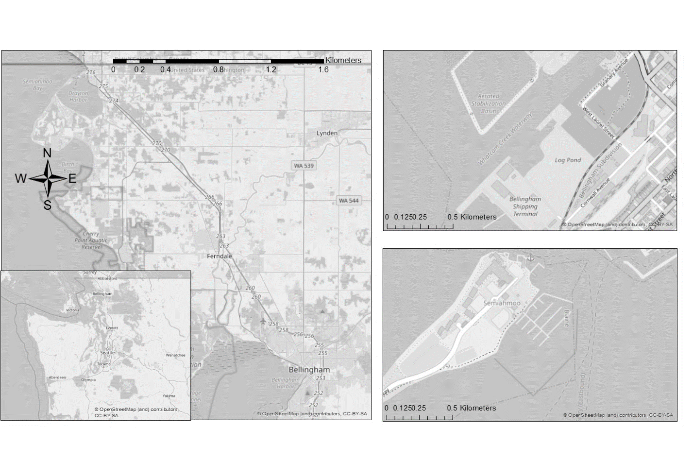

Figure 1: The two haul-out sites in northwestern Washington State, USA, where harbor seal surveys were conducted. Stars indicate haul-out sites, two stars at the waterfront indicate the two separate locations (East and West). Top right: Bellingham waterfront, bottom right: Semiahmoo marina. The Bellingham waterfront data from the two observation sites were combined (see Methods).

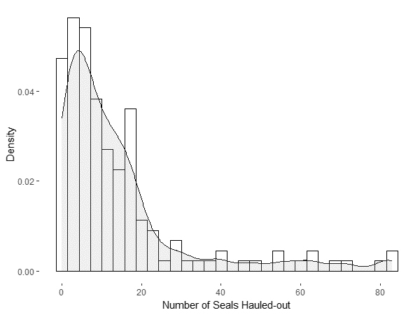

Figure 2: Histogram of harbor seals counts at Semiahmoo marina and Bellingham waterfront. The black lines with grey fill indicate density graph of harbor seal counts. Counts at the waterfront include numbers from both East and West locations.

a.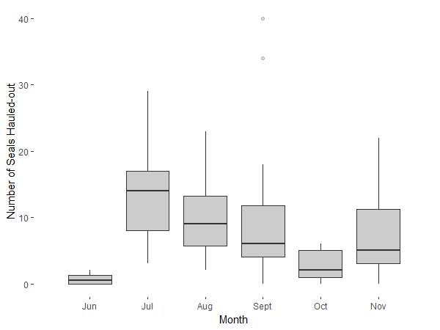

b. 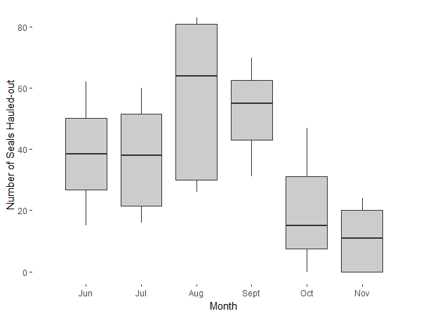

Figure 3: Number of harbor seals hauled-out relative to month at the a) Bellingham waterfront and b) Semiahmoo marina. Boxes indicate first quartile, median and third quartile haul-out numbers. Lines indicate minimum and maximum haul-out numbers. Dots indicate outliers. Counts at the waterfront include combined harbor seal counts from both East and West locations.

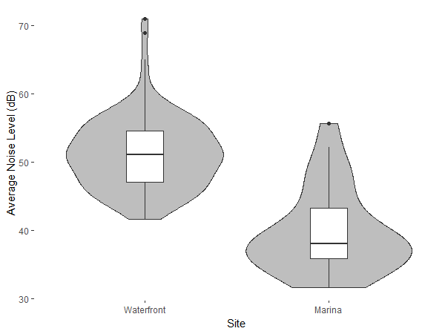

Figure 4: Probability density of in-air noise level in dB for the Semiahmoo marina and the Bellingham waterfront. Boxes inside density plots indicate first quartile, median and third quartile noise levels. Lines indicate minimum and maximum noise levels. Dots indicate outliers.

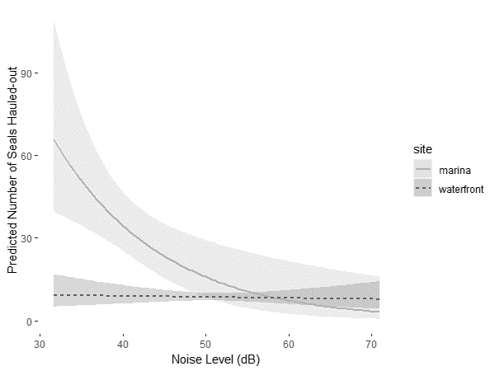

Figure 5: Log linear model of the expected seals counts across the range of noise levels for the Semiahmoo marina and the Bellingham waterfront. The grey area around the regression line shows 95% confidence intervals.